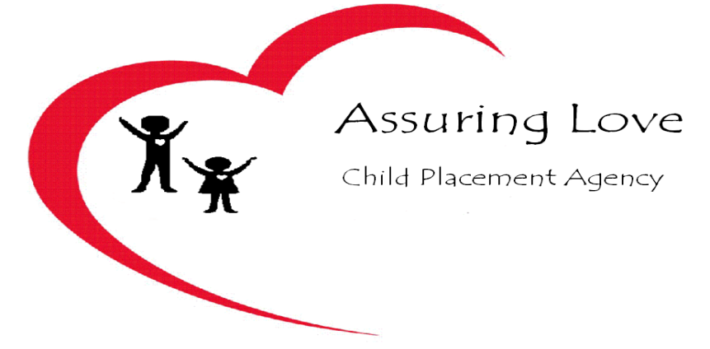
2013 Training Calendar

Training classes are from 10am to 2pm every second Saturday of the month.

May - 5/11/13  - Stages of Growth/Development  - Constructive Guidance/Discipline of  Children  - Looking Beyond Behavior  - Medical Consent | September – 9/14/13  - PAPH/Discipline  - Policies/Procedures  - Crisis Management
June – 6/8/13  - Fostering Self-Esteem  - Supervising for Safety  - Understanding Your Teenager | October – 10/12/13  - Helping Children Cope With Separation/Loss  - Documentation/Overview of FP Contract  - CPR/FIRST Aid
July – 7/13/13  - Helping Children Cope with Separation and Loss Issues  - Healthy Personal Boundaries  - Recognizing/ SBS, SIDS | November – 11/9/13  - Developmental Disorders  - Dealing with Difficult Children  - Understanding Early Childhood Brain Development
August – 8/10/13  - 12 Steps of Parenting  - Setting Consequences/Home Contract  - Psychotropic Medication  - Transportation | December – 12/14  - Preparing for State Licensing Visit  - Universal Precautions/ Communicable Diseases  - Child Abuse & Cultural Awareness

